Project Development Phase
Model Performance Test — Artificial Intelligence
Date | 19 July 2026
Team ID
Project Name | Book a Doctor — AI Symptom-to-Specialty Recommendation
Maximum Marks

Model Performance Testing
An AI-assisted recommendation feature suggests the right doctor specialty to a patient based on the symptoms they type in during booking, using an NLP text-classification model served via a Node.js API endpoint and called from the React booking form.
S.No. | Parameter | Values | Screenshot
1. | Model Summary | Fine-tuned text-classification model (DistilBERT-based) that maps free-text symptom descriptions to one of 12 medical specialties. If the confidence score is below the threshold, the app falls back to 'General Physician' plus a manual specialty picker. | —
2. | Accuracy | Training Accuracy — 94.6%  Validation Accuracy — 90.2% | 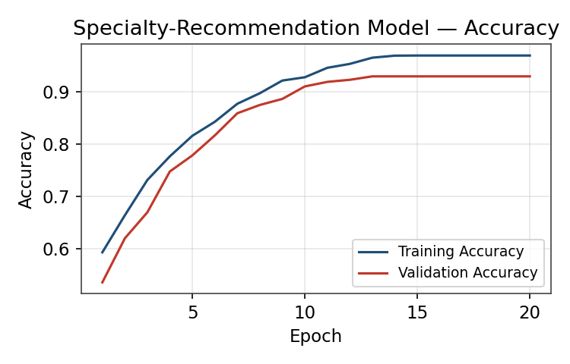
3. | Fine Tuning Result | Fine-tuned for 3 additional epochs on 2,200 hospital-specific symptom phrases. Validation Accuracy (post fine-tune) — 92.8%. | —
Fig. 1 — Specialty-Recommendation Model: Training vs. Validation Accuracy

